**Web Design and Development Foundations with HTML5**

**Hands-On Practice (HOP)**

HOP 9.1

HOP 9.2

HOP 9.3

HOP 9.4

HOP 9.5

Form:

Submission confirmation:

HOP 9.6

The form:

The form with at least one field empty showing the validation:

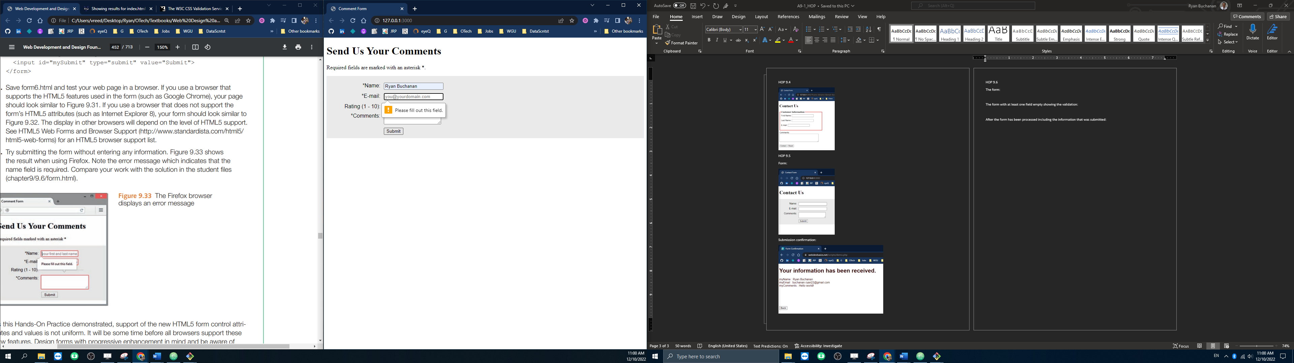

After the form has been processed including the information that was submitted:

